

|  |  |  |  |
| --- | --- | --- | --- |
|  | | **Model Development Phase Template** | |
|  |  | |  |
| Date |  | | 20 June 2025 |
|  |  | |  |
| Team ID |  | | SWTID1750057522 |
|  |  | |  |
| Project Title |  | | Unlocking Silent Signals: Decoding Body |
|  |  | | Language with Mediapipe |
|  |  | |  |
| Maximum Marks |  | | 4 Marks |
|  |  | |  |

**Initial Model Training Code, Model Validation and Evaluation Report**

The initial model training code will be showcased in the future through a screenshot. The model validation and evaluation report will include classification reports, accuracy, and confusion matrices for multiple models, presented through respective screenshots.

**Initial Model Training Code:**

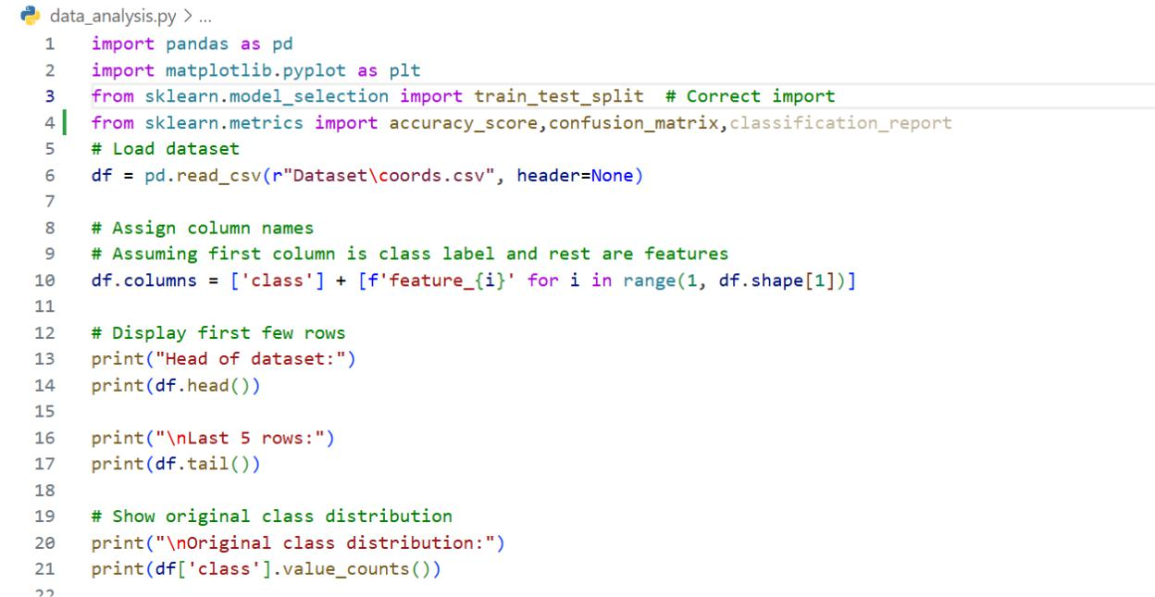

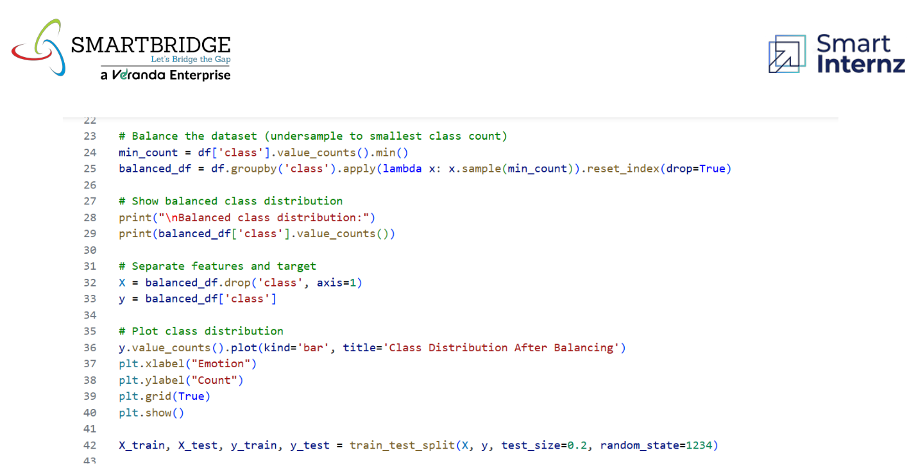

**Model Validation and Evaluation Report:**

|  |  |  |  |
| --- | --- | --- | --- |
| **Model** | **Classification Report** | **Accuracy** | **Confusion Matrix** |

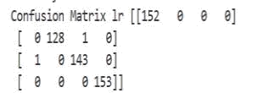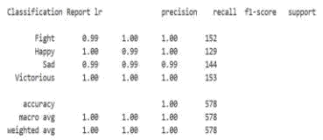

Logistic Regression

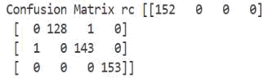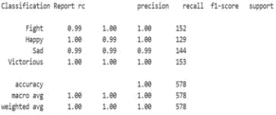

Ridge Classifier

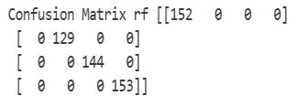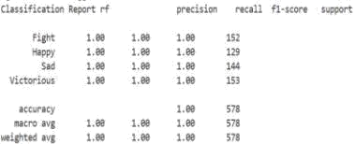

Random Forest Classifier

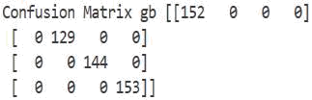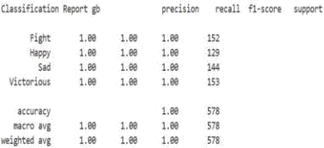

Gradient

Boosting



Classifier